**LEAP YEAR:**

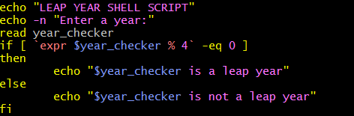

**OUTPUT:**

